**TASK 5**

**ECS Fargate Nginx Server Deployment with ALB and EFS using Terraform**

**Umar Satti**

Table of Contents

Task Description 3

Architecture Diagram 3

Task 1.1: NGINX and Dockerfile Configuration 4

Task 1.2: Test in Local Environment 5

Pre-requisites 5

Task 1.3: Create Terraform Project Structure 7

Task 1.4: Create S3 Bucket for Terraform Remote Backend 8

Task 1.5: Root Directory Files 10

Task 1.6: Configure VPC Module 17

Task 1.7: Configure Elastic Container Registry (ECR) Module 26

Task 1.8: Elastic File System (EFS) Module 28

Task 1.9: Configure Task Definition Module 30

Task 1.10: Elastic Container Service (ECS) Module 36

Task 1.11: Application Load Balancer Module 39

Task 1.12: Execute Terraform Commands 42

Task 1.13: Validate Infrastructure Deployment in AWS Console 43

Task 1.11.2: Push Docker Image to ECR 56

Task 1.11.3: Confirm Application is Accessible 58

Task 1.12: Clean Up 59

Task 1.13: Troubleshooting 59

# Task Description

Set up a highly available and scalable infrastructure on Amazon ECS Fargate using Terraform. Includes a VPC, security groups, ECS cluster, ECS service with a custom Docker image, ALB, and EFS for persistent storage.

# Architecture Diagram

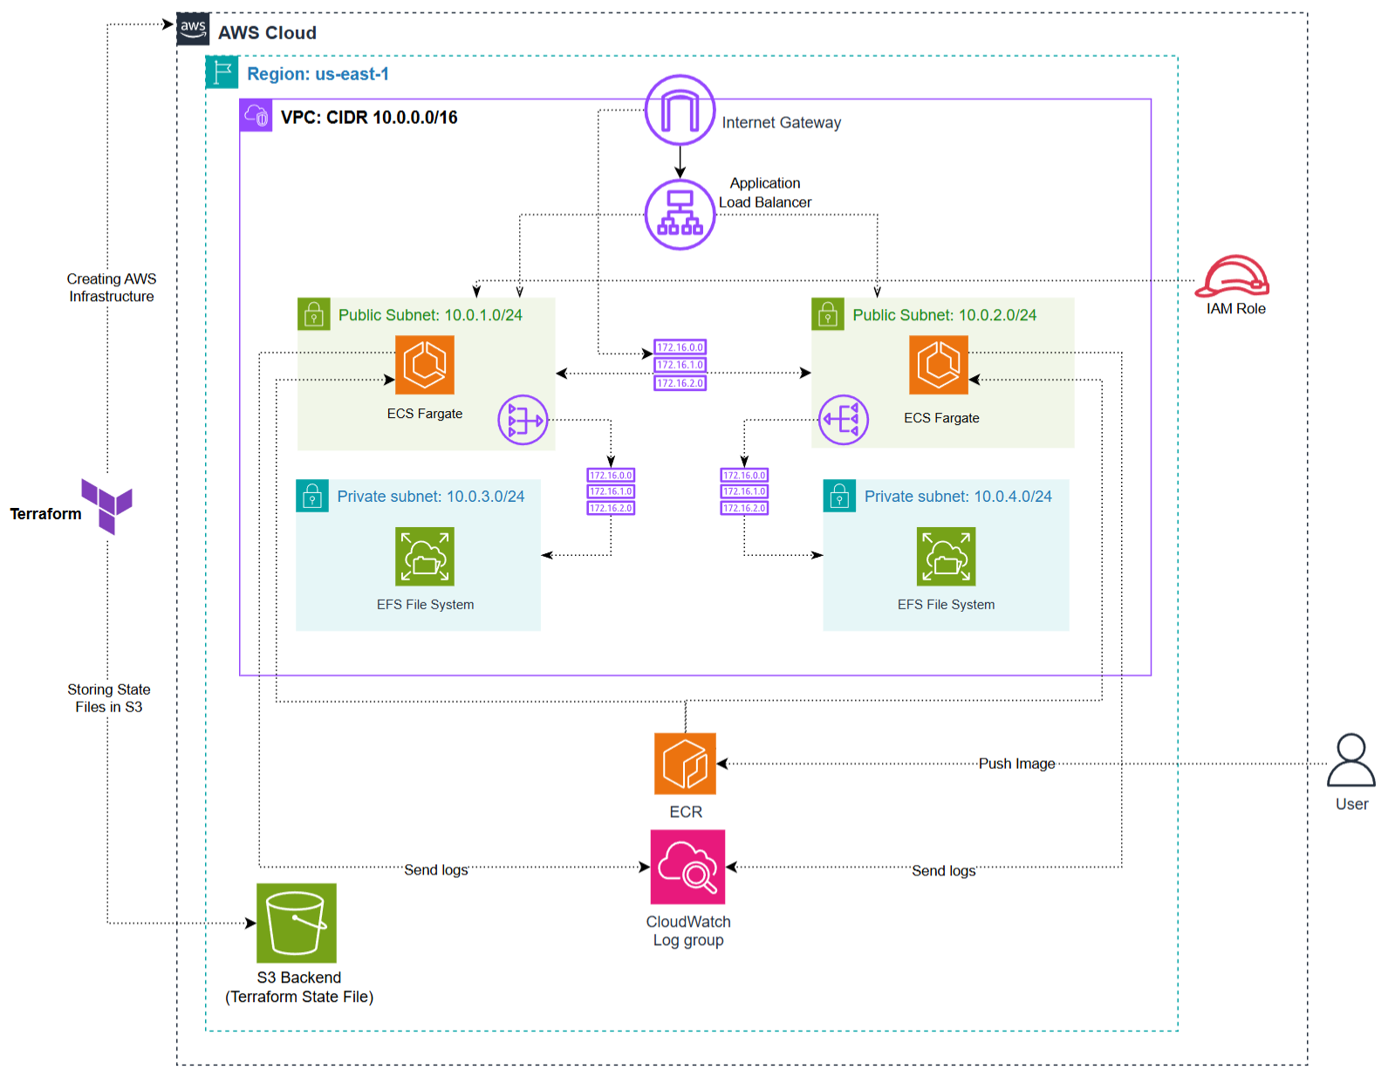

## Task 1.1: NGINX and Dockerfile Configuration

The first step of the project is building a custom Docker image that runs an NGINX server hosting a static webpage. This image is then uploaded to ECR and used by ECS Fargate.

**Step 1: Create Static Website (index.html)**

A simple HTML page is placed in the /static/index.html directory. It serves as the application content rendered by the NGINX container.

**Step 2: Create Dockerfile**

* **Custom configuration:** Removing the default config avoids the standard welcome page and allows full control over routing and behavior.
* **Static file deployment:** The static site is included directly in the container, so ECS tasks launch instantly without fetching external data.
* **Foreground execution:** daemon off ensures the container stays alive and does not exit immediately.
* **Port exposure:** Required for the ALB and ECS service to route incoming web traffic.

**Step 3: Create NGINX configuration file**

* **Root directory mapping:** Points NGINX to the correct path where the container stores static files.
* **server_name _:** This ensures NGINX accepts traffic regardless of domain.
* **try_files directive:** Provides proper 404 handling if files are missing.

With the Dockerfile, NGINX configuration, and static website in place, the image can now be tested locally before uploading to Amazon ECR. This ensures that the application runs successfully in a controlled environment and behaves as expected.

## Task 1.2: Test in Local Environment

Before deploying the containerized NGINX application to AWS ECS Fargate, the image must first be tested locally. This ensures that:

* The Dockerfile is valid.
* NGINX configuration works correctly.
* Static content is being served properly.
* No runtime errors occur before pushing the image to ECR.

Testing locally removes guesswork and validates that the container will behave correctly once deployed in AWS.

### Pre-requisites

* **Docker Desktop installed** and running
* Project directory containing:
  + /static/index.html
  + /Dockerfile
  + /nginx.conf

**Step 1: Build the Docker Image**

Navigate to the root of the project folder (where the Dockerfile exists), and run:

* docker build -t nginx-app:latest .

**Explanation**

* **docker build** compiles the Docker image using the Dockerfile in the current directory.
* **-t nginx-app:latest** assigns a name (nginx-app) and tag (latest).
* The resulting image becomes the local container that mirrors what will later be deployed on ECS.

**Step 2: Run the Container Locally**

Start the container using the following command:

* docker run -d -p 8080:80 --name nginx-app nginx-app:latest

**Explanation**

* **-d** runs the container in detached mode
* **-p 8080:80** maps local port **8080** to container port **80** (where NGINX listens)
* **--name nginx-app** assigns a readable container name
* **nginx-app:latest** is the image created earlier

**Step 3: Verify Container Status**

* Once running, inspect the container:
  + docker ps -a
* To confirm the image exists:
  + docker images
* What to verify:
  + The container should show **STATUS: Up**
  + The image **nginx-app** should be listed locally

**Step 4: Test in Browser**

Open any browser and go to http://localhost:8080. The page should display the custom webpage written in index.html

This confirms:

* Dockerfile works
* NGINX config is valid
* Static file was copied correctly
* Container exposes port 80 properly
* Image is ready to be pushed to Amazon ECR

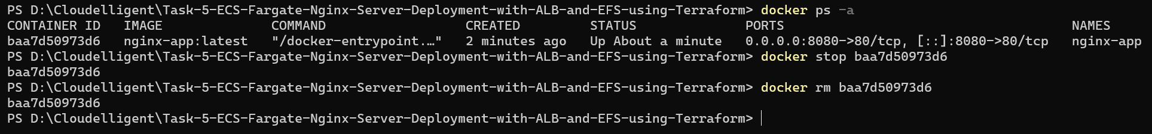

## Task 1.3: Create Terraform Project Structure

**Steps:**

1. Create a terraform.tf file in the root directory. This file defines the AWS provider, provider version, AWS region, and the S3 backend for storing Terraform state files.
2. Create an S3 bucket in the same AWS region to store Terraform state files (explained in Task 1.4 below).
3. Create a main.tf file in the root directory. This connects modules together, passes outputs from one module to another, and passes variables between them.
4. Create a variables.tf file in the root directory. This file defines variables by description and type as key-value pairs. These contain arguments for parameters such as VPC name, CIDR block, ECR URIs, and more.
5. Create an outputs.tf file in the root directory. This file exposes important module outputs such as ALB DNS name after deployment.
6. Create a modules directory that contains 6 total modules including VPC, Task definition, ECR, ECS, EFS, and ALB. Each module contains its own individual main.tf, variables.tf, and outputs.tf files.

The terraform project directory structure looks like this:

## Task 1.4: Create S3 Bucket for Terraform Remote Backend

**Steps:**

1. Log in to the AWS Management Console. Navigate to S3 using the search bar at the top of the console page.
2. Click on **Create Bucket** button.
3. Choose **General Purpose**, add a globally unique bucket name, and make sure the AWS Region is the same as Terraform.
4. Click **Create Bucket**.
5. Update **terraform.tf** file in root directory to reference this S3 bucket in the backend block.

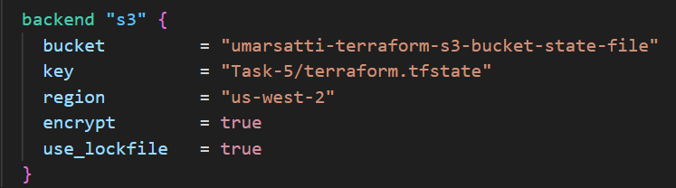

Once the S3 bucket is created in the AWS Management Console and referenced in the Terraform backend configuration, Terraform automatically begins storing and versioning state files in this bucket.

In this case, the S3 bucket named **umarsatti-terraform-s3-bucket-state-file** is used as the remote backend, as defined in the **provider.tf** file. The backend block ensures all state information is centralized, secure, and persistent across multiple users or workstations.

The screenshot shown below shows the exact file path inside the S3 bucket:  
**S3 > Buckets > umarsatti-terraform-state-file-s3-bucket > Task-5 > terraform.tfstate**

This confirms that:

* Terraform successfully initialized the backend and wrote the state file to the S3 bucket.
* The **terraform.tfstate** file contains metadata about all deployed AWS resources (VPC, Subnets, Security groups, etc.).
* Every terraform plan, apply, or destroy operation reads and updates this file automatically.
* The locking mechanism (enabled by **use_lockfile = true**) ensures that no two processes modify the state simultaneously, preventing state corruption.

## Task 1.5: Root Directory Files

The root directory of the Terraform project acts as the **control layer** for the entire infrastructure deployment.  
While each AWS service (VPC, ECS, ALB, EFS, ECR, Task Definition) is isolated into its own module, the root directory ties everything together by:

* Defining the provider and backend.
* Passing variables into modules.
* Connecting module outputs to other modules.
* Exposing global outputs after deployment.
* Organizing environment-specific configuration (tfvars).

This ensures that the project is modular, scalable, reusable, and easy to maintain.

**terraform.tf:**

This file configures the AWS provider, specifies its version, and defines the remote backend used for storing Terraform state files. It also enables state locking using S3 and controls the region of deployment.

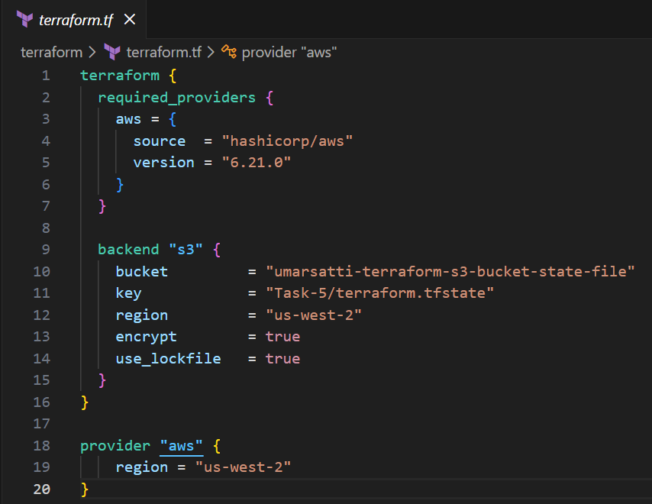

**Explanation:**

* **backend "s3"** block defines where the Terraform state file is stored.
* **use_lockfile = true** ensures no two Terraform operations run at the same time.
* The remote backend provides resilience and collaboration.

**main.tf:**

This is the central orchestrator of the infrastructure. It declares and connects all Terraform modules.

**Purpose**

* Loads modules for VPC, ECR, Task Definition, EFS, ECS, and ALB.
* Passes required inputs into each module.
* Wires module outputs into dependent modules.
* Creates dependency order between infrastructure components.

**Explanation:**

* The VPC module is loaded first because most other modules depend on it.
* ECR is independent and provides an ECR repo URI for the Task Definition.
* The Task Definition depends on EFS and ECR.
* ECS requires Task Definition, ALB target group, VPC subnets, and ECS SG.
* ALB needs VPC ID, subnets, and the ALB SG.

This modular design separates networking, database, security, compute, and container image handling into cleanly isolated units.

**terraform.tfvars**

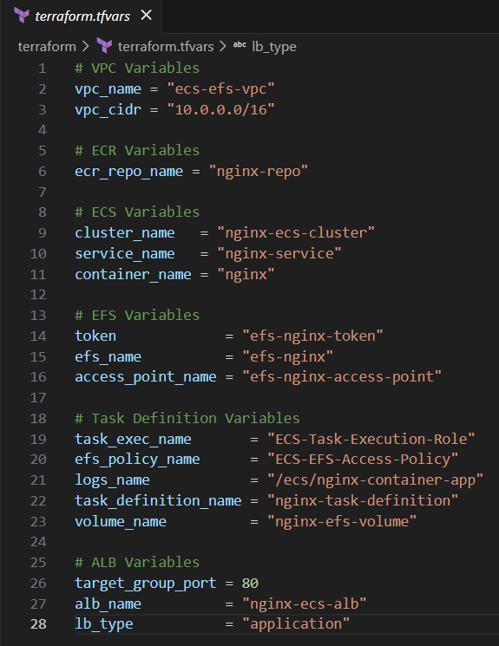

The terraform.tfvars file provides the actual input values Terraform uses during deployment. It separates configuration data from the module code, ensuring cleaner, reusable, and environment-specific setups. Each variable defined here directly corresponds to the infrastructure components deployed in AWS.

**VPC Variables**

* **vpc_name** and **vpc_cidr** specify the name and IP range of the VPC that forms the foundational network for the entire environment.
* These values ensure your VPC is uniquely identifiable and properly segmented.

**ECR Variables**

* **ecr_repo_name** defines the name of the Amazon ECR repository where the Nginx Docker image will be stored.
* Terraform uses this to create a private container registry for ECS deployments.

**ECS Variables**

* **cluster_name, service_name,** and **container_name** provide the names for the ECS Cluster, ECS Service, and container definition.
* These values ensure ECS resources are created with consistent and meaningful names.

**EFS Variables**

* **token, efs_name,** and **access_point_name** define the EFS file system and its access point.
* These values are used by ECS tasks to mount persistent shared storage using the EFS Access Point.

**Task Definition Variables**

* **task_exec_name** and **efs_policy_name** define IAM resources required by ECS Tasks.
  + Execution role: allows ECS to pull images, publish logs, etc.
  + EFS policy: grants tasks permission to mount EFS.
* **logs_name** specifies the CloudWatch Logs group for container logs.
* **task_definition_name** sets the name of the ECS Task Definition.
* **volume_name** defines the name of the EFS volume attached to the task.

**ALB Variables**

* **target_group_port** specifies which port the ALB Target Group listens on (HTTP 80 in this case).
* **alb_name** defines the Application Load Balancer's name.
* **lb_type** specifies the load balancer type (here it is set to "application" for ALB).

**variables.tf:**

The **variables.tf** file defines all input variables required by the Terraform root module. These variables parameterize the infrastructure, making the configuration modular, reusable, and environment-agnostic. Each variable includes a type and description to improve clarity and ensure Terraform validates values before applying changes.

**VPC Variables**

* **vpc_name** and **vpc_cidr** specify the foundational networking configuration.
* These values determine the VPC’s name and address range, which all other resources depend on.

**ECR Variables**

* **ecr_repo_name** provides the name of the Amazon ECR repository where the Nginx container image will be stored.
* This allows the ECR module to dynamically create and manage the repository.

**ECS Variables**

* **cluster_name, service_name, and container_name** define the ECS Cluster, ECS Service, and the container name used inside the Task Definition.
* These variables ensure consistent naming across compute resources.

**EFS Variables**

* **token, efs_name, and access_point_name** provide values required to create the EFS file system and Access Point.
* These variables allow ECS tasks to attach persistent storage.

**Task Definition & IAM Variables**

* **task_exec_name** defines the name of the ECS Task Execution Role.
* **efs_policy_name** specifies the IAM policy that grants EFS access permissions.
* **logs_name** defines the CloudWatch Log Group for storing container logs.
* **task_definition_name** provides the Task Definition identifier.
* **volume_name** specifies the EFS volume name used within the ECS task.

**ALB & Target Group Variables**

* **target_group_port** determines the port the ALB Target Group listens on (e.g., HTTP 80).
* **alb_name** sets the name of the Application Load Balancer.
* **lb_type** defines the type of load balancer (e.g., "application" for ALB).

**outputs.tf:**

This file exposes important outputs after Terraform completes its deployment.

* **ecr_repo_url** returns the full private ECR repository URI where container images are pushed.
* **alb_dns_name** outputs the Application Load Balancer’s DNS name, which is used to access the deployed web application.

These outputs are useful for verification and for quickly locating key resource details without navigating the AWS console. They also make it easy to reuse infrastructure components in future stages or other dependent systems.

## Task 1.6: Configure VPC Module

This section explains each Terraform configuration file located inside the **VPC module** (modules/vpc) and how they work together to create the complete networking layer required for the ECS Fargate, ALB, and EFS infrastructure.

**main.tf**

**Local Variables**

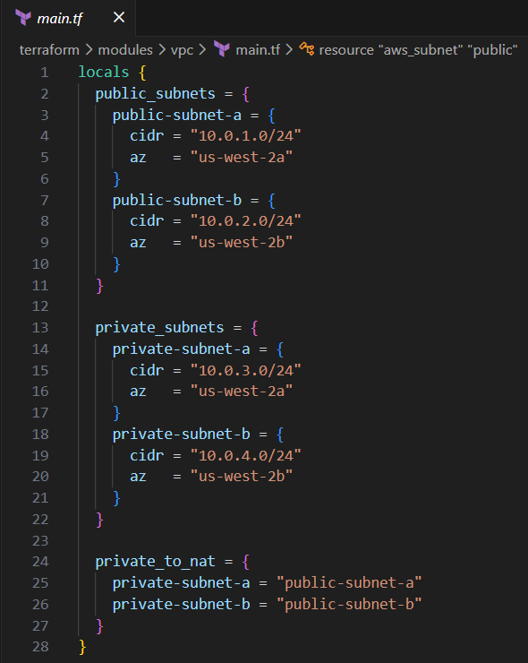

The module begins with a **locals** block defining three important data structures:

**1. public_subnets**

A map describing all public subnets, including:

* Subnet name (key)
* CIDR block along with its actual value (value)
* Availability Zone along with its actual value (value)

**2. private_subnets**

A map defining all private subnets with similar structure. These subnets are used for ECS tasks and EFS mount targets, keeping them isolated from the public internet.

**3. private_to_nat**

A mapping that assigns each private subnet to the correct NAT Gateway residing in the matching public subnet (such as private subnet in Availability Zone B to public subnet in Availability Zone B). This ensures proper outbound routing for private resources.

**Purpose of locals**

* Allows clean, dynamic subnet creation using **for_each** argument
* Simplifies scaling to more subnets/AZs
* Eliminates repetitive code

**Virtual Private Cloud (VPC)**

This resource creates the main VPC that will hold all networking components.

* **cidr_block** is passed from the root module, making the VPC customizable.
* **enable_dns_hostnames = true** allows resources like ECS tasks and EFS endpoints to use internal DNS.
* Tagged using the **vpc_name** variable for easy identification.

**Public Subnets**

Public subnets are created dynamically using **for_each = local.public_subnets.** Each subnet receives:

* The CIDR block defined in locals
* An availability zone
* Automatic public IP assignment using **map_public_ip_on_launch = true**
* A friendly tag equal to the map key (e.g., "public-subnet-a")

These subnets are used for:

* ALB (Application Load Balancer)
* NAT Gateways
* ECS

**Private Subnets**

Created using **for_each = local.private_subnets**. Each private subnet receives:

* CIDR and AZ values from locals (local variables)
* No public IP assignment
* Tags matching their map key

Private subnets are used for EFS mount targets and do not have direct Internet access.

**Internet Gateway (IGW)**

Creates and attaches an Internet Gateway to the VPC.

* Allows public subnets to communicate with the Internet
* Required before NAT Gateways can function

Tagged for easy visibility.

**Elastic IPs (EIP) for NAT Gateways**

A separate EIP is created for each public subnet using **for_each = aws_subnet.public**. This ensures one NAT Gateway per Availability Zone, supporting high availability.

**NAT Gateways**

Each NAT Gateway is deployed inside a public subnet:

* Uses the corresponding Elastic IP
* Allows outbound Internet access for private subnets
* Ensures private ECS tasks can pull images from ECR

The module deploys **one NAT per public subnet**, aligning with AWS best practices.

**Route Tables**

**Public Route Table**

Used by all public subnets.

* Routes all outbound traffic (0.0.0.0/0) to the Internet Gateway
* Ensures ALB and NAT Gateways have Internet access

**Private Route Tables**

A separate private route table is created for each private subnet using **for_each = aws_subnet.private.**

Each private route table:

* Routes Internet traffic through the **correct NAT Gateway** due to local.private_to_nat variable
* Keeps private resources hidden from the public Internet

**Route Table Associations**

**Public Associations**

Links each public subnet to the public route table.

**Private Associations**

Links each private subnet to its corresponding private route table.

These associations finalize the network routing behavior.

**Security Groups**

Three security groups are created inside the VPC:

**1. ALB Security Group**

Allows:

* Inbound HTTP traffic from the Internet on port 80
* All outbound traffic allowed

Attached to the Application Load Balancer.

**2. ECS Security Group**

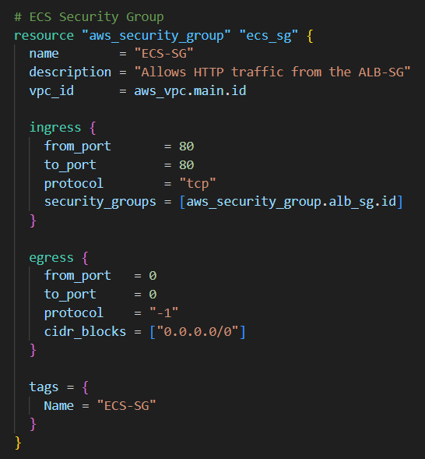

Allows:

* Inbound traffic **only from the ALB** on port 80
* Outbound traffic allowed

This ensures:

* Only the ALB can communicate with ECS tasks
* ECS tasks cannot be accessed directly from the public Internet

**3. EFS Security Group**

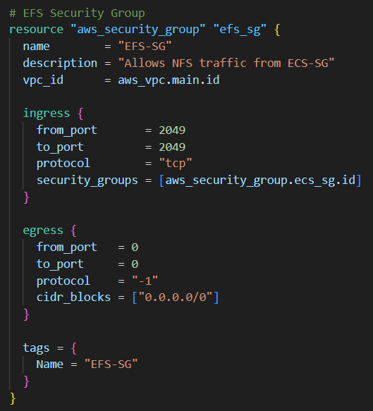

Allows:

* Inbound traffic to port **2049** (NFS)
* Only from the ECS security group

Purpose:

* ECS tasks can mount EFS
* EFS is protected from all external traffic

This creates a secure flow in which traffic routes from **Internet to ALB to ECS Tasks to EFS**

**variables.tf**

This module accepts two variables:

**1. vpc_name**

Used for tagging the VPC for identification.

**2. vpc_cidr**

Defines the IPv4 range used by the VPC.

These variables allow the VPC module to be reused across different environments (dev, staging, prod).

**outputs.tf**

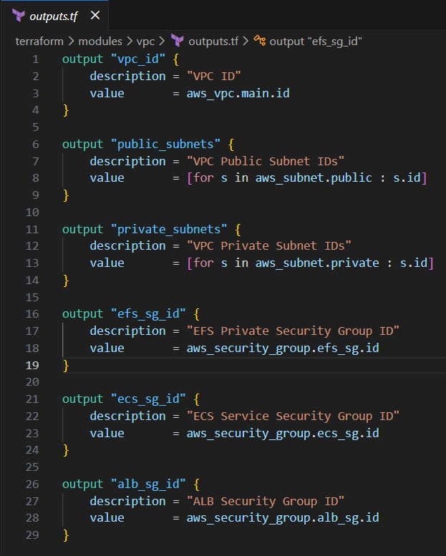

The following outputs provide critical information for other modules.

**1. vpc_id**

Needed by:

* ALB module
* ECS module
* EFS module

**2. public_subnets**

A list of public subnet IDs, used by:

* ALB for load balancer placement
* NAT Gateway deployment
* ECS services if needed

**3. private_subnets**

A list of private subnet IDs, used by:

* ECS tasks
* EFS mount targets

**4. efs_sg_id**

Security group ID used by EFS module to allow ECS tasks to access the file system.

**5. ecs_sg_id**

Security group for ECS tasks, passed to the ECS module.

**6. alb_sg_id**

Security group for ALB, passed to the ALB module.

## Task 1.7: Configure Elastic Container Registry (ECR) Module

This section explains all Terraform configuration files inside the **ECR module** (modules/ecr).  
This module provisions a private Elastic Container Registry that stores the Docker image used by the Nginx application running on ECS Fargate.

**main.tf**

This file creates a single Amazon ECR repository:

**Explanation**

* **name** pulled from the input variable **ecr_repo_name**, allowing flexible naming for different environments.
* **image_tag_mutability = "MUTABLE"** allows tags (such as latest) to be overwritten. This is helpful during rapid development and testing, where images are frequently updated.
* **force_delete = true** ensures that Terraform can destroy the ECR repository even if images still exist, preventing cleanup issues during repeated deployments.
* **AES-256 encryption** allows all container images stored in the registry to be encrypted by default for security.
* **scan_on_push = false** disables image vulnerability scanning on upload. This simplifies CI/CD pipelines but can be enabled later for production security requirements.

**Note:** This registry provides a secure and private location to store the Nginx Docker image.  
Later in the deployment process, the ECS Task Definition will reference this repository URL when pulling the application image.

**variables.tf**

* Defines a single variable **ecr_repo_name**, representing the repository name used when creating the ECR registry.
* Keeping this as an external input (in terraform.tfvars) ensures:
  + The module is reusable for any application.
  + Repository names can differ across environments without modifying module code.

**outputs.tf**

* Exposes **ecr_repo_url**, the full ECR URI such as:  
  123456789012.dkr.ecr.us-west-2.amazonaws.com/nginx-repo
* This output is essential because **ECS Task Definition** needs this URL to pull the Docker image.

## Task 1.8: Elastic File System (EFS) Module

This section explains all Terraform configuration files inside the **EFS module** (modules/efs).  
The purpose of this module is to create a shared Elastic File System that the ECS tasks will use to store or persist application data.

**main.tf**

This file provisions the EFS File System, its Mount Targets, and an Access Point.

**EFS File System**

**Explanation:**

* **creation_token**  
  Ensures the EFS filesystem is created idempotently. If Terraform runs multiple times, AWS will not create duplicate EFS volumes.
* **encrypted = true**  
  Enables server-side encryption using AWS-managed keys.  
  This secures all data stored in the filesystem.
* **tags**  
  Helps identify this EFS filesystem inside AWS.

This creates the core network file system that ECS tasks will mount.

**EFS Mount Targets**

**Explanation:**

* EFS requires **one mount target per Availability Zone (AZ)** for ECS tasks to connect to it.
* The **for_each** block creates two mount targets, one for each private subnet.
* This ensures:
  + High availability
  + ECS tasks in any AZ can connect to EFS with low latency

**Key inputs:**

* **var.private_subnet_ids**  
  Passed from the VPC module, ensuring mount targets are created in private subnets only.
* **security_groups**  
  EFS mount targets use the provided security group, allowing only ECS tasks to connect using NFS port 2049.

**EFS Access Point**

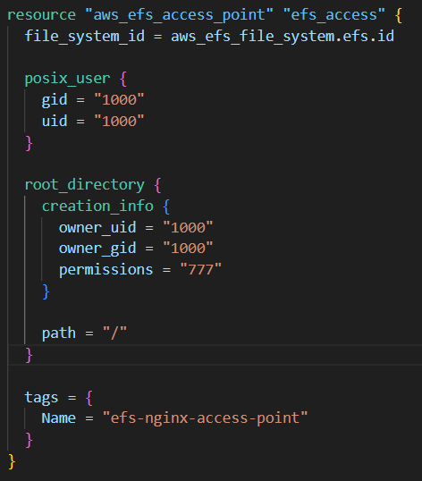

**Explanation:**

An Access Point provides a standardized entry path for ECS containers.

* **posix_user block** sets a default Linux user (UID/GID 1000) for file access.
* **root_directory block** ensures:
  + A root directory exists for the application
  + It is owned by UID/GID 1000
  + It has open permissions (777) for simplicity and compatibility with containers
* **Access Point benefits:**
  + Consistent permissions
  + Isolated directory
  + Cleaner ECS task volumes configuration

This Access Point will later be referenced directly in the ECS task definition.

## Task 1.9: Configure Task Definition Module

This section explains the Terraform files inside the Task Definition module (modules/task_definition), which defines how an **Nginx container** should run inside ECS Fargate with EFS storage.

**main.tf**

**ECS Task Execution Role**

* Creates an **IAM Role** that ECS tasks assume during execution.
* assume_role_policy allows ECS to use this role.
* This role enables ECS tasks to:
  + Pull container images from ECR
  + Send logs to CloudWatch
  + Access AWS APIs during runtime, including mounting EFS volumes

**IAM Policy Attachment (AWS Managed)**

* Attaches the **AmazonECSTaskExecutionRolePolicy**, which provides:
  + ECR read access
  + CloudWatch Logs permissions
  + Basic ECS runtime permissions

**Custom EFS Access Policy**

* Creates a custom IAM policy granting ECS tasks permission to:
  + Mount EFS volumes (ClientMount)
  + Write to EFS (ClientWrite)
  + Access the root directory of EFS (ClientRootAccess)
  + Describe EFS file systems and mount targets
* Attaches this policy to the ECS Task Execution Role.
* This allows ECS tasks to securely access the specified EFS file system and access point.

**CloudWatch Log Group**

* Creates a CloudWatch Logs group for container logs.
* retention_in_days = 7 ensures logs are automatically deleted after 7 days, controlling costs.

**ECS Task Definition**

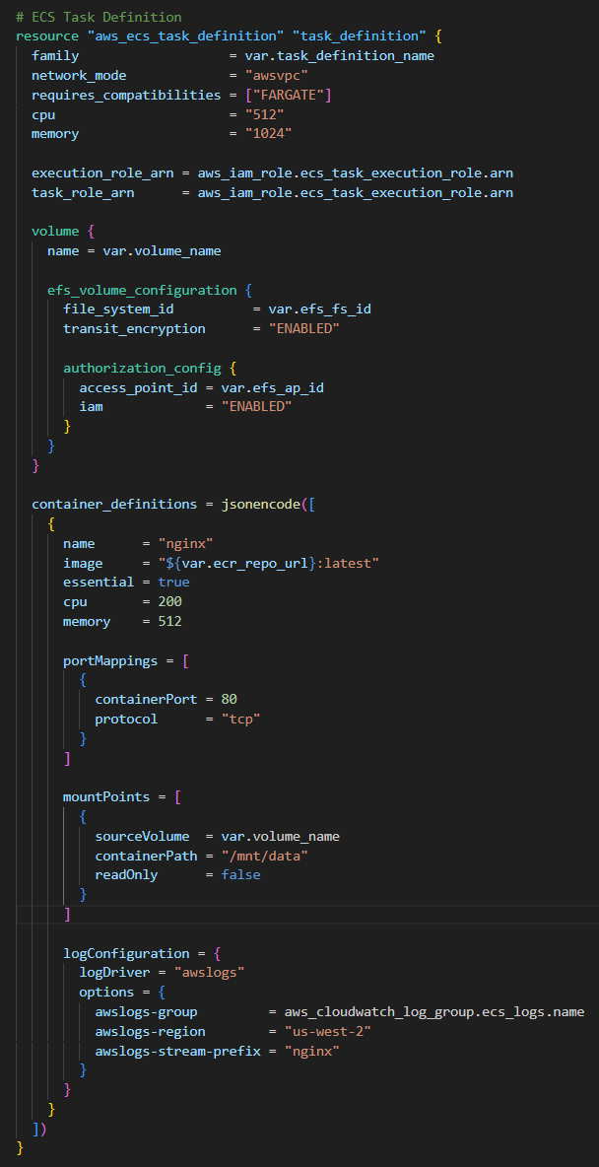

Defines how the Nginx container runs on ECS Fargate. Key settings:

* **General Settings**
  + family: Groups revisions of the same task definition.
  + network_mode = "awsvpc": Required for Fargate tasks.
  + requires_compatibilities = ["FARGATE"] specifies the launch type.
  + cpu = 512 and memory = 1024 allocate task-level CPU and memory.
* **Task and Execution Role**
  + Both execution_role_arn and task_role_arn use the ECS Task Execution Role created above.
  + This enables container operations like pulling images, logging, and accessing EFS.
* **Volumes and EFS Configuration**
  + A volume is defined using EFS:
    - file_system_id and access_point_id are provided via variables.
    - transit_encryption = "ENABLED" ensures encrypted network traffic between ECS and EFS.
    - iam = "ENABLED" in authorization_config ensures IAM-based access control for the volume.
* **Container Definitions**
  + Defines a single **Nginx container**:
    - image: Pulled from the ECR repository (${var.ecr_repo_url}:latest)
    - cpu and memory define container resource allocation.
    - essential = true ensures ECS stops the task if the container fails.
* **Port Mapping**
  + Maps container port 80 to allow traffic routing from ECS.
* **Mount Points**
  + Mounts the EFS volume at /mnt/data inside the container.
  + readOnly = false allows writing to the volume.
* **Log Configuration**
  + Sends container logs to CloudWatch using the log group defined above.
* Uses awslogs driver with region and stream prefix configured.

**variables.tf**

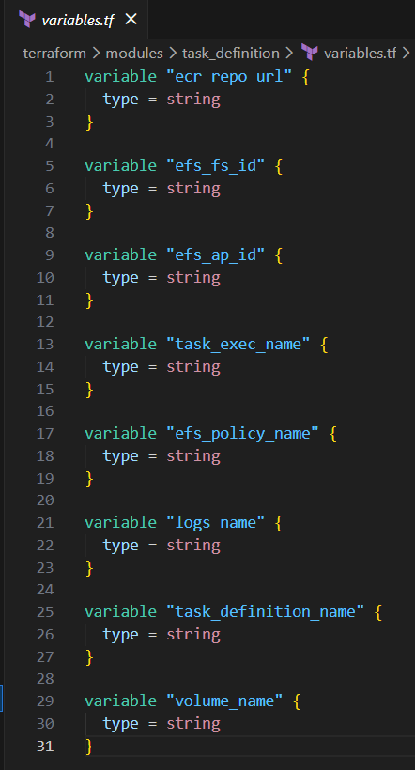

Defines input variables for the module:

* **ecr_repo_url:** URL of the ECR image repository
* **efs_fs_id:** ID of the EFS filesystem
* **efs_ap_id:** ID of the EFS access point
* **task_exec_name:** Name of the ECS Task Execution Role
* **efs_policy_name:** Name of the custom EFS policy
* **logs_name:** Name of the CloudWatch log group
* **task_definition_name:** ECS Task Definition family name
* **volume_name:** Name of the volume used for mounting EFS

**outputs.tf**

* task_definition_arn:
  + Exposes the ARN of the ECS Task Definition.
  + Required by the ECS Service module to deploy tasks using this definition.

## Task 1.10: Elastic Container Service (ECS) Module

This module defines the ECS infrastructure needed to run the containerized application defined in the Task Definition module. It creates an **ECS cluster** and an **ECS Fargate service** that runs tasks using that cluster.

**main.tf**

**ECS Cluster**

* aws_ecs_cluster creates an ECS cluster to run tasks.
* Key settings:
  + name: Cluster name, provided via variable cluster_name.
  + setting: Enables **Container Insights** (enhanced) for monitoring and observability.
  + configuration.execute_command_configuration.logging: Enables ECS Execute Command logging to CloudWatch for debugging.

**Cluster Capacity Providers**

* aws_ecs_cluster_capacity_providers sets the **capacity provider strategy** for the cluster.
* Here, it uses **FARGATE** as the capacity provider, with a base of 1 task and weight of 100.
* This ensures all tasks in this cluster run on Fargate (serverless ECS compute).

**ECS Service**

ECS Service deploys and manages tasks using the ECS cluster.

**Key features:**

* **General Settings**
  + name: Name of the ECS service (service_name)
  + cluster: ECS cluster ID
  + task_definition: Uses the ARN of the ECS Task Definition (from Task 1.9)
  + desired_count = 2: Runs 2 task replicas
  + launch_type = "FARGATE": Serverless compute
  + platform_version = "LATEST": Ensures newest Fargate features
  + scheduling_strategy = "REPLICA": ECS maintains the desired number of task replicas
  + enable_execute_command = true: Allows interactive command execution in containers
* **Deployment Configuration**
  + strategy = "ROLLING": Updates tasks gradually during deployment to avoid downtime
* **Network Configuration**
  + assign_public_ip = true: Tasks get public IPs
  + security_groups: Attaches specified security group
  + subnets: Deploys tasks into public subnets
* **Load Balancer Integration**
  + Configures ECS tasks to work with an **Application Load Balancer (ALB)**
  + target_group_arn: Target group where traffic is sent
  + container_name and container_port: Maps traffic to the correct container and port (port 80)

**variables.tf**

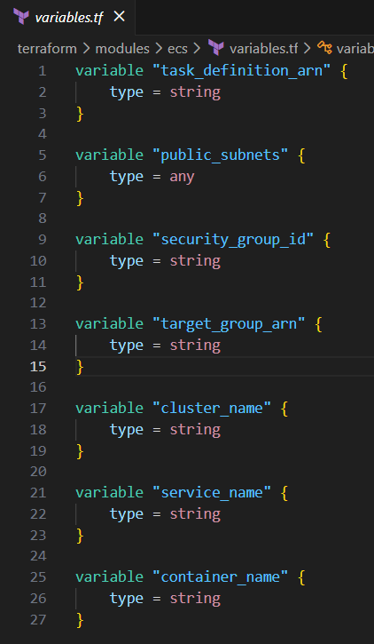

Defines input variables for the module:

* **task_definition_arn:** ARN of the ECS Task Definition to run
* **public_subnets:** List of public subnet IDs for Fargate tasks
* **security_group_id:** Security group ID for task networking
* **target_group_arn:** ARN of the ALB target group
* **cluster_name:** Name of the ECS cluster
* **service_name:** Name of the ECS service
* **container_name:** Name of the container in the task definition (used for ALB routing)

## Task 1.11: Application Load Balancer Module

This module provisions an **Application Load Balancer** and its supporting resources, enabling ECS services to receive HTTP traffic from the internet.

**main.tf**

**Application Load Balancer (aws_lb)**

* Creates an **internet-facing ALB** that distributes incoming traffic to ECS tasks.
* Key settings:
  + **name:** Name of the ALB (from alb_name variable).
  + **internal = false:** Makes the ALB publicly accessible.
  + **load_balancer_type:** Set via variable (ALB or NLB)
  + **security_groups:** Attach a security group controlling access to the ALB.
  + **subnets:** Deploys the ALB in public subnets for internet access.
  + **enable_deletion_protection = false:** Allows ALB deletion if needed.

**Target Group (aws_lb_target_group)**

* Defines a **target group** for routing traffic from the ALB to ECS tasks.
* Key settings:
  + **name:** Target group name, here "nginx-target-group".
  + **port & protocol:** Traffic is sent over HTTP to the container port.
  + **protocol_version = "HTTP1":** Uses HTTP/1.1.
  + **target_type = "ip":** ECS tasks registered by IP address, required for Fargate.
  + vpc_id: Associates the target group with the correct VPC.

**Listener (aws_lb_listener)**

* Configures the **listener** for the ALB that receives incoming requests.
* Key settings:
  + load_balancer_arn: Connects the listener to the ALB.
  + port & protocol: Listens on port 80 using HTTP.
  + default_action: Forwards all requests to the ip_target_group target group.

**variables.tf**

Defines inputs for the module:

* **vpc_id:** VPC where ALB and target group reside.
* **public_subnets:** Public subnets to deploy the ALB.
* **alb_security_group_id:** Security group for ALB access.
* **target_group_port:** Port ECS tasks listen on (container port, e.g., 80).
* **alb_name:** Name of the ALB.
* **lb_type:** Load balancer type (application for ALB, network for NLB).

**outputs.tf**

Exposes key ALB information for other modules (e.g., ECS service):

* **alb_arn:** ARN of the ALB for referencing in ECS service.
* **target_group_arn:** ARN of the target group for ECS service registration.
* **alb_dns_name:** Public DNS name of the ALB to access the web application.

## Task 1.12: Execute Terraform Commands

This section documents the series of Terraform CLI commands executed to deploy, validate, and destroy the WordPress environment.

**Note:** To perform this task, the user must be in the root directory of Terraform project where the provider.tf and the root main.tf files are stored.

**Step 1: terraform init**

Initializes the working directory by downloading the required provider plugins and connecting them to the configured backend (S3).

**Step 2: terraform validate**

Performs a syntax and logic check on all configuration files in the directory. Outputs an error if the logic or syntax is incorrect.

**Step 3: terraform plan**

Generates an execution plan showing all actions Terraform will perform to reach the desired state (resource creation, updates, or deletions).

**Step 4: terraform apply**

terraform apply --auto-approve command creates 39 resources. After infrastructure creation, the terminal displays the following outputs:

* alb_dns_name = "nginx-ecs-alb-1498337006.us-west-2.elb.amazonaws.com"
* ecr_repo_url = "504649076991.dkr.ecr.us-west-2.amazonaws.com/nginx-repo"

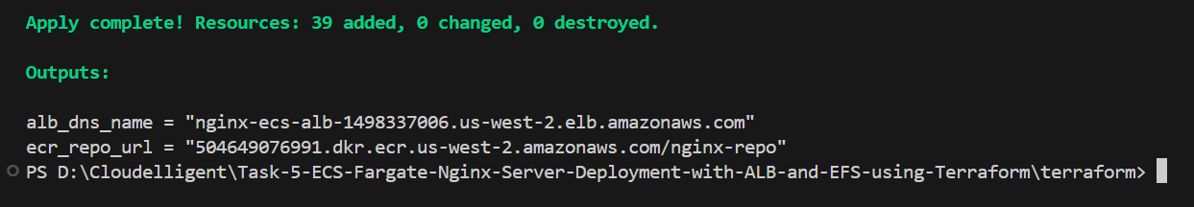

## Task 1.13: Validate Infrastructure Deployment in AWS Console

After running **terraform apply**, Terraform provisions the entire containerized application environment, including networking, compute, storage, IAM, and orchestration resources. In this step, verify that all deployed components exist and are configured correctly in the AWS Console.

**Verify VPC Creation**

1. Sign in to the AWS Management Console.
2. Navigate to **VPC** using the search bar and click **Your VPCs**.
3. Verify that a VPC named **ecs-vpc** (or your custom name) has been created.

**Expected Configuration:**

* **CIDR Block:** 10.0.0.0/16
* **DNS Hostnames:** Enabled
* **Purpose:** This VPC acts as the isolated network environment for the ECS Fargate and EFS application

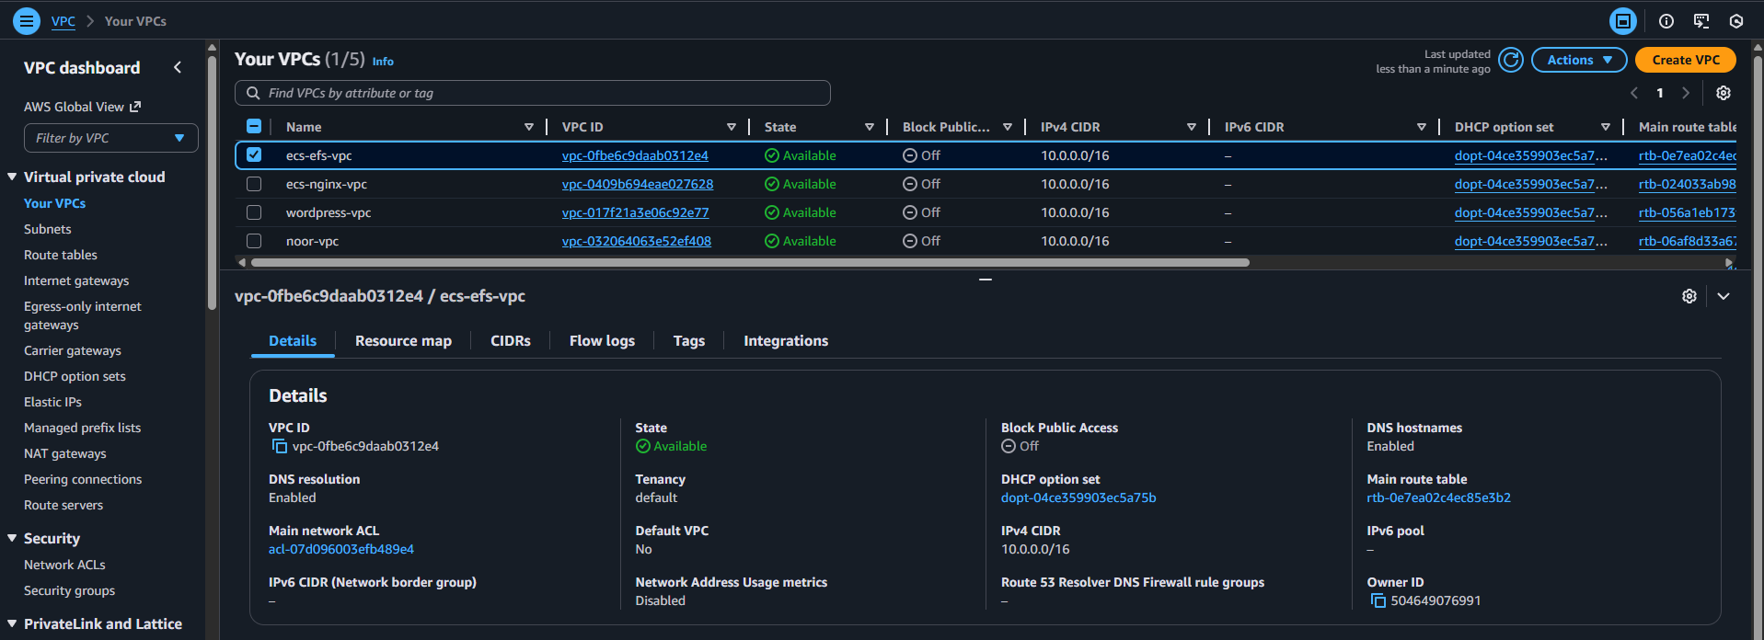

**Verify Internet Gateway (IGW) Creation**

1. In the VPC console, choose **Internet Gateways**.
2. Confirm that an Internet Gateway named **ecs-efs-vpc-igw** exists and is attached to the VPC created earlier. This gateway allows the ECS service to communicate with the internet.

**Verify Subnets Creation**

**Public Subnets**

1. In the VPC console, select **Subnets** in the left navigation bar.
2. Confirm the existence of:
   * public-subnet-a with IPv4 CIDR **10.0.1.0/24**
   * public-subnet-b with IPv4 CIDR **10.0.2.0/24**

These subnets host the Application Load Balancer (ALB) and ECS Fargate ENIs (public IP assigned).

**Private Subnets**

1. In the VPC console, select **Subnets**.
2. Confirm the existence of:
   * private-subnet-a with IPv4 CIDR **10.0.3.0/24**
   * private-subnet-b with IPv4 CIDR **10.0.4.0/24**

These subnets host:

* Private ECS networking (for internal workloads)
* EFS mount access
* Any private resources (if applicable)

**Verify NAT Gateways and Elastic IPs**

1. In the VPC console, select **NAT Gateways** located in the left navigation bar.
2. Verify the existence of two NAT Gateways:
   * One in each public subnet
   * Each associated with its allocated Elastic IP
   * Status should be **Available**
   * **Names:** nat-gw-public-subnet-a / nat-gw-public-subnet-b

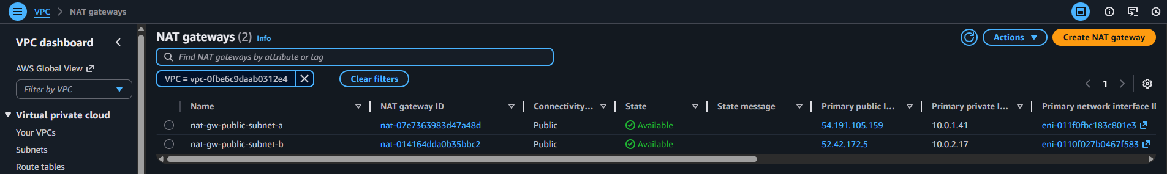

**Verify Route Tables**

**Verify Public Route Table and Routes Creation**

1. In the VPC console, choose **Route tables** located on the left navigation panel.
2. Select the route table named **Public-Route-Table**.
3. Check that it contains a route to the Internet Gateway with the destination **0.0.0.0/0**.
4. Under **Subnet Associations**, verify that **public-subnet-a** and **public-subnet-b** are associated with this route table as shown under **Explicit subnet associations (2)**.

**Verify Private Route Tables and Routes Creation**

1. In the VPC console, choose **Route tables** located on the left navigation panel.
2. Select both the route tables named **private-subnet-a-rt** and **private-subnet-b-rt**.
3. Check that both contain a route to the NAT gateway with the destination **0.0.0.0/0**.
4. Under **Subnet Associations**, verify that **private-subnet-a** and **private-subnet-b** are associated with their own route table shown under **Explicit subnet associations (1)**.

**Verify Security Group Creation**

**Load Balancer Security Group**

1. In the VPC console, choose **Security groups** located on the left navigation panel.
2. Locate the **ALB-SG** security group
3. It should have the following inbound rules:

|  |  |  |  |
| --- | --- | --- | --- |
| **Type** | **Protocol** | **Port range** | **Source** |
| HTTP | TCP | 80 | 0.0.0.0/0 |

4. Outbound rules should allow all traffic.

**ECS Security Group**

1. In the VPC console, choose **Security groups** located on the left navigation panel.
2. Locate the **ECS-SG** security group
3. It should have the following inbound rules:

|  |  |  |  |
| --- | --- | --- | --- |
| **Type** | **Protocol** | **Port range** | **Source** |
| HTTP | TCP | 80 | ALB-SG |

4. Outbound rules should allow all traffic.

**EFS Security Group**

1. In the VPC console, choose **Security groups** located on the left navigation panel.
2. Locate the **EFS-SG** security group
3. It should have the following inbound rules:

|  |  |  |  |
| --- | --- | --- | --- |
| **Type** | **Protocol** | **Port range** | **Source** |
| HTTP | TCP | 2049 | ECS-SG |

4. Outbound rules should allow all traffic.

**Verify ECR Creation**

1. Sign in to the AWS Management Console.
2. Navigate to **ECR** service using the search bar at the top and then click **Repositories** under **Private registry** located in the left navigation bar.
3. Verify that the **nginx-repo** repository was created with a URI.

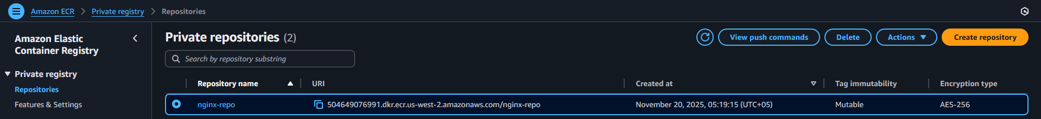

**Verify EFS File System and Access Point**

1. Navigate to **EFS** console using the search bar.
2. Select **File systems** in the left navigation bar and verify that the file system named **efs-nginx** is deployed and assigned to the VPC created earlier
3. Under Networks tab, confirm that EFS file system in deployed in two Availability Zones (us-west-2a and us-west-2b)

1. Now click **Access Points** in the left navigation bar.
2. Confirm that access point named efs-nginx-access-point exists.

**Verify IAM Roles and Policies**

1. Navigate to **IAM** service and then select **Roles** in the left navigation bar.
2. Use search to locate the **ECS-Task-Execution-Role**.
3. Click on this IAM role and confirm attached policies:
   * **AmazonECSTaskExecutionRolePolicy**
   * Custom **EFS** access policy named **ECS-EFS-Access-Policy**

**Verify CloudWatch Log Group**

1. Navigate to **CloudWatch** service and select **Log groups** in the left navigation bar.
2. Verify the log group exists:
   * Name: /ecs/nginx-container-app

**Verify Task Definition Creation**

1. Sign in to the AWS Management Console.
2. Navigate to **ECS** service using the search bar at the top and then click **Task definitions** located in the left navigation bar.
3. Verify that a task definition named **nginx-task-definition** is created.

**Verify ECS Cluster, Service, and Tasks**

1. Sign in to the AWS Management Console.
2. Navigate to **ECS** service using the search bar at the top.
3. Click **Clusters** located in the left navigation bar.
4. Verify that a cluster named **nginx-ecs-cluster** is already created.
5. Click on this **nginx-ecs-cluster**.

1. There should be a **Service** running with an **Active** status and **Deployments and tasks** showing **Tasks** running.
2. Click on **Tasks** tab. It should show Tasks in a **Stopped** state. This is because the **Tasks** are failing as there are **NO** images that have been **Pushed** to the ECR repositories (e.g. wordpress image).

**Verify ALB and Target Group**

1. Navigate to **EC2** service and then click **Load Balancers** located in the left navigation bar.
2. Verify:
   * ALB named **ecs-alb** exists
   * Assigned to public subnets
   * Using ALB-SG

1. Click **Listeners**
   * **HTTP:80** Forward to Target Group

1. Navigate to **Target Groups**
   * Confirm the target group exists
   * Targets should show **healthy** after tasks are running and the image has been pushed to ECR.

**Note:** It should display 0 Healthy targets before Docker image has been pushed to ECR repository. This screenshot is taken after the image was pushed to ECR repository.

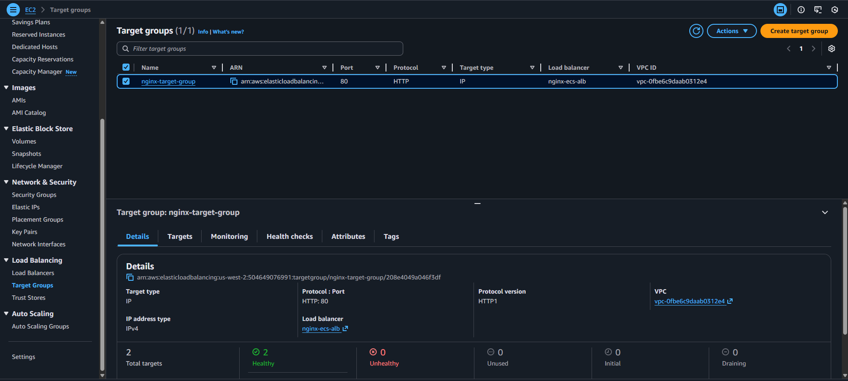

### Task 1.11.2: Push Docker Image to ECR

1. Navigate back to **ECR** service using the search bar.
2. Select **Repositories** under **Private Registry.**
3. Click the repository named **nginx-repo**.
4. Click **View push commands**.
5. Run the displayed commands locally on a terminal (Docker Desktop must be running).

* aws ecr get-login-password --region us-west-2 | docker login --username AWS --password-stdin <Account_ID>.dkr.ecr.us-west-2.amazonaws.com
* docker build -t nginx-repo .
* docker tag nginx-repo:latest <Account_ID>.dkr.ecr.us-west-2.amazonaws.com/nginx-repo:latest
* docker push <Account_ID>.dkr.ecr.us-west-2.amazonaws.com/nginx-repo:latest

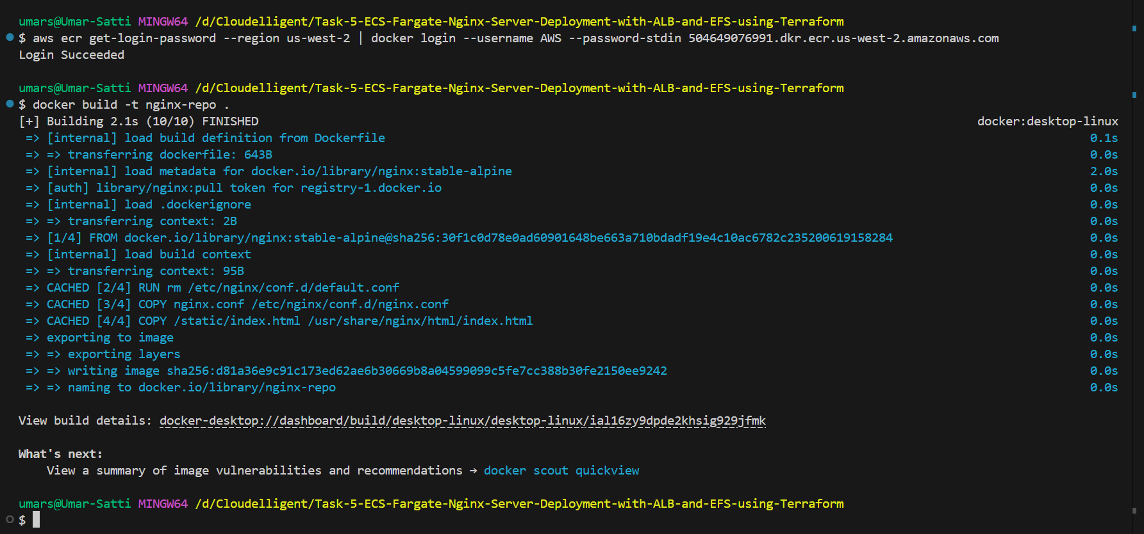

**Verify the images have been pushed**

1. Click the **nginx-repo** repository.
2. An image should be available with the **latest** tag.

**Verify the Service and Tasks are running**

1. Navigate to **ECS** service using the search bar at the top and then click **Clusters** located in the left navigation bar.
2. Under the **Service** tab, it should display two tasks running successfully (2/2).

### Task 1.11.3: Confirm Application is Accessible

1. Navigation to EC2 service using the search bar.

2. Scroll down and click **Load Balancers** located in the left navigation bar.

3. Locate the **ALB DNS** **Name** assigned and copy it.

4. Open a web browser and paste the DNS.

5. It should display a static webpage.

## Task 1.12: Clean Up

To delete the resources, run ***terraform destroy*** or ***terraform destroy --auto-approve***

## Task 1.13: Troubleshooting

**Issue 1: EFS Not Mounting to ECS Tasks**

**Problem Description:**ECS Tasks consistently failed to start, and the task logs displayed EFS mount errors such as “failed to resolve EFS mount target.”

**Root Cause:**The Terraform VPC module did not have enable_dns_hostnames = true enabled, which is required for EFS.

EFS mount targets depend on DNS names (e.g., fs-xxxx.efs.<region>.amazonaws.com).  
If DNS hostnames are disabled, ECS cannot resolve the EFS DNS endpoint, causing the mount operation to fail.

**Solution:**The VPC configuration in Terraform was updated to include:

* enable_dns_hostnames = true

Once applied, EFS DNS names resolved correctly and ECS tasks were able to mount the file system successfully.

**Issue 2: EFS Mount Failure Due to Invalid Container Path**

**Problem Description:**  
Even after fixing DNS hostname support, ECS tasks still failed with mount-related errors. The container mount path was shown as invalid in task logs.

**Root Cause:**  
The **container path** for the EFS volume was incorrectly set to **‘/’**, which is the root directory of the container filesystem. ECS does not allow mounting over the container root path.

**Solution:**  
The EFS volume mount path inside the container was changed to a valid directory such as:

* /mnt/data
* /mnt/efs

After updating the ECS task definition, the tasks started successfully and the EFS volume mounted as expected.

**Issue 3: Terraform State Lock Preventing Destroy Operation**

**Problem Description:**Attempting to execute ***terraform destroy --auto-approve*** resulted in the following message:

* Error acquiring the state lock

**Root Cause:**Changes were made to Terraform configuration files after the resources were deployed, causing Terraform to detect a state mismatch and lock the state to prevent accidental corruption.

**Solution:**The state lock was manually released using:

* terraform force-unlock <LOCK_ID>

After unlocking, terraform destroy was completed successfully.

